# Chapter 2.5: Use Case Diagram

Use case diagram is a dynamic or behavior diagram drawn in UML which shows the functionality of the system using actors and use cases. Use cases are a set of actions, services and functions that the system needs to perform. Various components of use case diagram are

* Actors: It represents the people who use the system and represented in UML by stick figures.
* Use cases: It defines the process in the system represented by oval shapes.
* Associations: This shows the relation between use cases and actors.
* System Boundary Boxes: It refers to rectangular box where system is posted.

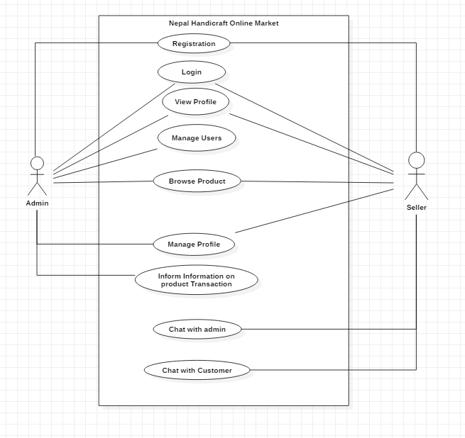

Figure 2: Use Case Diagram of Nepal Handicraft Online Market

|  |  |
| --- | --- |
| Justification | flow how user and admin logs and register in the system |
| Primary Actors | Admin/User |
| Secondary Actors | N/A |
| Primary Flow | 1. Normal User Initially register into the system leaving profile information 2. The user logs the system through the profile information |
| Alternative Flow | N/A |

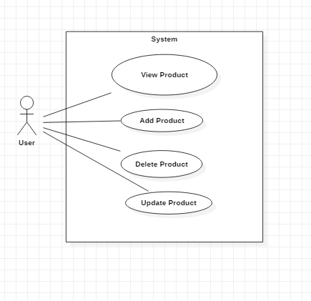

Figure 4: Product Entry/ Delete/ Update/ View

|  |  |
| --- | --- |
| Justification | This use case shows how the user can upload the product data, update the data if any mistake, delete the product information if not needed and view the product detail |
| Actors | User |
| Supporting Actors | N/A |
| Primary Flow | 1. User Add the product data in the system. 2. User update the product data by searching the product and changing it data 3. Delete the product data if not needed |
| Alternative Flow | N/A |

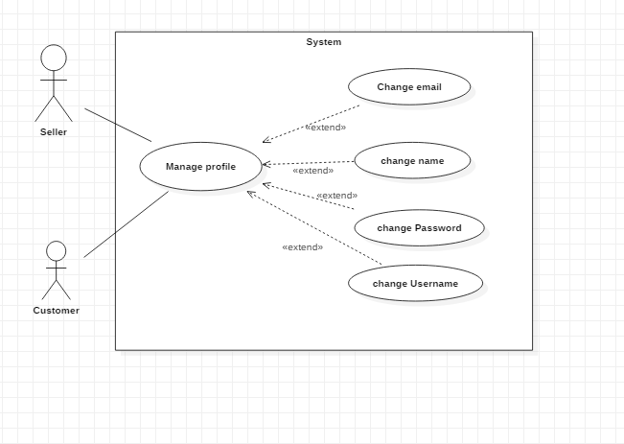

Figure 5: Profile Management

|  |  |
| --- | --- |
| Justification | This use case show how user can manage their profile |
| Actors | Users |
| Alternate Actor | N/A |
| Primary Flow | 1. User change their name, email, phone number, username and password if needed. |
| Alternate Flow | N/A |

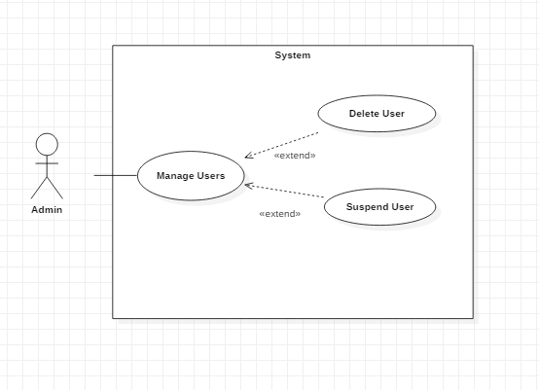

Figure 6: User Management

|  |  |
| --- | --- |
| Justification | This use case show what the admin can do to manage the users. |
| Actors | Admin |
| Alternate Actor | N/A |
| Primary Flow | 1. The admin can suspend the user who are doing the work that doesn’t follow the rule. 2. The admin can delete the user who are not using. |
| Alternate Flow | N/A |

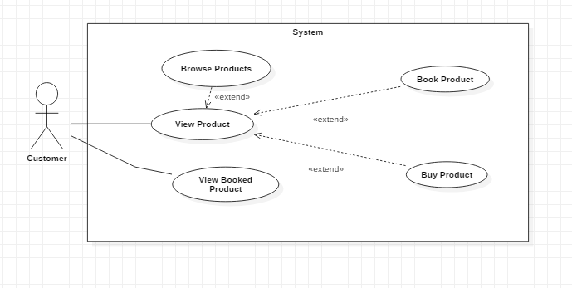

|  |  |
| --- | --- |
| Justification | This show the what customer can do when they view product |
| Actors | Customer |
| Secondary Actors | N/A |
| Primary Flow | 1. The customer can book and buy the product after they have viewed the product. 2. They can see what product they have booked |
| Secondary Flow | N/A |

The figures above represent the use case diagram of this project. The interaction of users and admin in the system in shown in the figure above. These diagram shows what functions are performed by the users and admin. I have also shown the various behaviors done by the actors in the use cases diagram above.